Table of Contents

Purpose of this Guide 1
Moodle Account Login (Statistics, Billing, Tools) 2
Video Demo for Admin Login 2
EdPuzzle Teacher Login 2
Creating New Users in Moodle 2
Course Link to Covid Rapid Test Training (CRTT) 3
User Tours can be Confusing 3
Creating EdPuzzle Content 3
EdPuzzle Work Around for Learners 3
Learner Recordings via Google Forms 4
Self Assessment Options 4
JLX Trying Out a Moodle Lesson: 4
JLX Showing Options for a Moodle Quiz: 4
Activity Completion Settings 4
Copying Courses in Moodle 5
Reporting: Learner Viewing Stats 5
Stats on EdPuzzle Videos: 5
Reporting for Quizzes, Lessons, etc.: 6

Purpose of this Guide
The guide is meant to collect all the foundational and fundamental information that FloodLAMP needs to finish the content creation and learning experience development process of their v1 training program.

Moodle Account Login (Statistics, Billing, Tools)
This is the GENERIC Moodle Cloud Login page where you are logging in as a System Admin for any Moodle Cloud:
https://moodlecloud.com/app/en/login
To log in as ADMIN on this page use:
Username: Floodlamp
Password: ​​LAMPlamp11!!

This is the FLOODLAMP Moodle Cloud Login Page where you are logging in as any FLOODLAMP user.
https://floodlamp.moodlecloud.com/
To log in as ADMIN on this page use the following, but NOTE! this is the SAME USER:
Username: Floodlamp
Password: ​​LAMPlamp11!!

Video Demo for Admin Login
https://www.loom.com/share/7f146c8094574642ba369998cef7656b

EdPuzzle Teacher Login
User: floodlamplab@gmail.com
Pass: FFrT2)#y7=33_7i

Creating New Users in Moodle
- 100% self-enrollment - just send any new user sign up Moodle URL:
- https://floodlamp.moodlecloud.com/login/signup.php
- Walkthrough here: https://www.loom.com/share/567a9f46dfc948ca8aa70a187c6d2b5e

Course Link to Covid Rapid Test Training (CRTT)
https://floodlamp.moodlecloud.com/course/view.php?id=5

User Tours can be Confusing
We’ve disabled the User Tours. When User Tours are used for a large and complex Moodle they might be very useful but in a simple, single course with self-enrollment, the User Tours confused some test users.
How to: https://moodle.org/mod/forum/discuss.php?d=380051
Admin page: https://floodlamp.moodlecloud.com/admin/tool/usertours/configure.php

Creating EdPuzzle Content
https://www.loom.com/share/81c4c711f8bb42cf92a509401d4acba5
NOTE! Once EdPuzzle Content has been LINKED via this integration, if you move the video on Edpuzzle side, rename it, or put it in a new folder the integration won’t be able to find it. It will show a page like this instead: “This assignment is currently inactive. Ask your teacher if you have any questions.”
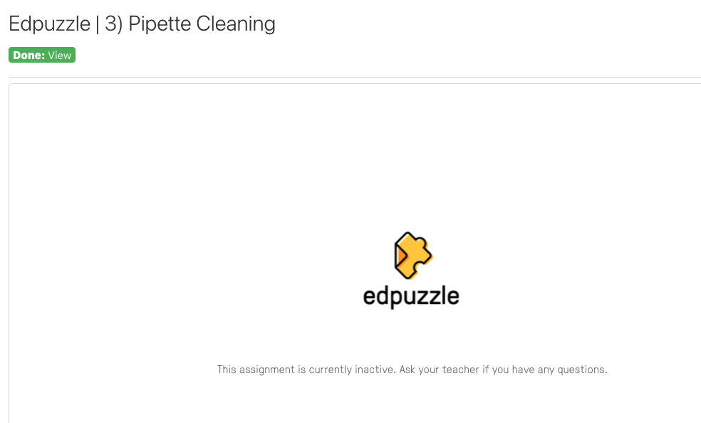

EdPuzzle Work Around for Learners
JLX created directions right in the Moodle Course for the learners.
It is very easy for them! https://floodlamp.moodlecloud.com/mod/page/view.php?id=101

Learner Recordings via Google Forms
https://www.loom.com/share/fca35a9acf004bb9897f0d2579d3eb91

Self Assessment Options
Great forum post discussing Options:
https://moodle.org/mod/forum/discuss.php?d=394827
(TLDR; Quiz is likely the most efficient option)

JLX Trying Out a Moodle “Lesson”:
https://www.loom.com/share/0bf0f4bb045248d581c98daa477e3b23

JLX Showing Options for a Moodle “Quiz”:
https://www.loom.com/share/a05617d516ee4fbf957b6037c36d4101

Activity Completion Settings
How to Page
- JLX set the current Course to a Default Activity Completion for External Tools (E.g. EdPuzzle) and Pages. This setting changes the default settings from Manual, meaning the student would have to Mark it Complete, to Automatic so that when they’ve viewed it, it shows as Done.
  - Be aware as you add any new content that the completion settings are not set to manual (Moodle will show this for manual: “Student can manually mark the activity as completed”)
  - Update new content to: “Show activity as complete when conditions are met” which will be followed by: “Student must view this activity to complete it”
- JLX already updated all the current pages in the course to these settings:
  - “Show activity as complete when conditions are met”
  - “Student must view this activity to complete it”
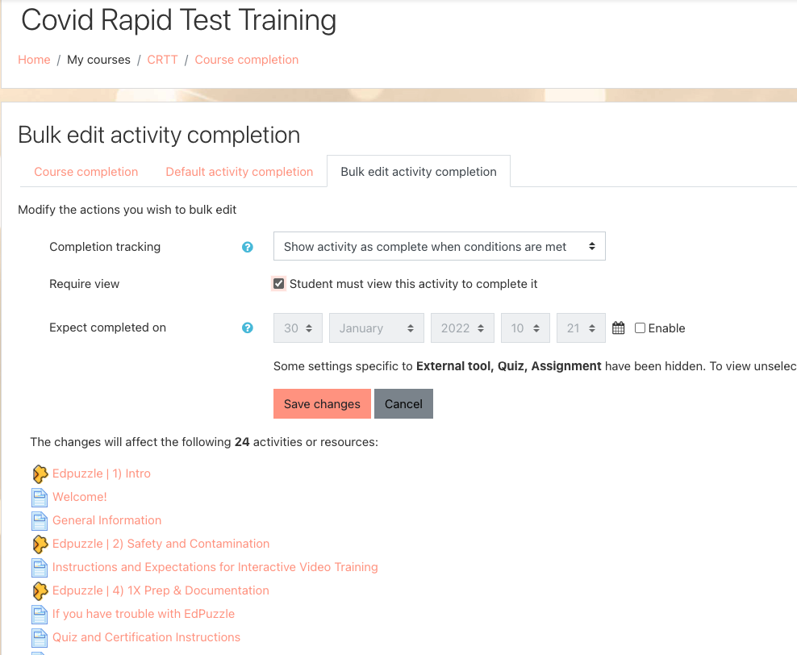

Copying Courses in Moodle
https://www.loom.com/share/f707fec983764f40a949abd3e588722d
NOTE! In addition to recreating EdPuzzle video links in the new course, you will ALSO have to create a NEW Google Form to keep the learner videos separated in different folders.

Reporting: Learner Viewing Stats

Stats on EdPuzzle Videos:
https://www.loom.com/share/dec6ebac812a48858ce2dd0c36d80986

Reporting for Quizzes, Lessons, etc.:

